

MBARARA UNIVERSITY OF SCIENCE AND TECHNOLOGY
FACULTY OF COMPUTING AND INFOMATICS
BACHELOR OF INFORMATION TECHNOLOGY

Name: MUGARURA DICKENS
Reg No: 2024/BIT/123
Lecturer: Dr. Antony Bwaana & Dr. Robert Mugonza
Emails: antonybwaana82@gmail.com, robertmugonza@must.ac.ug

Table of Contents
1. Project Overview
2. Design Decisions
3. Development Process
4. Testing and Deployment
5. Conclusion and Reflection
6. Appendix

1. Project Overview
Purpose
The Healthcare Appointment System is a web-based platform designed to simplify medical appointment booking for patients and streamline schedule management for healthcare providers.

Target Audience:
- Patients: Book, reschedule, or cancel appointments.
- Doctors/Clinics: Manage availability and view patient bookings.

Key Functionalities
- User authentication (login/registration with password hashing).
- Search doctors by specialty, location, or availability.
- Interactive Google Maps integration with geocoding.
- Mobile-responsive design (Bootstrap framework).
- Automated email reminders (PHP Mailer integration).

Wireframes

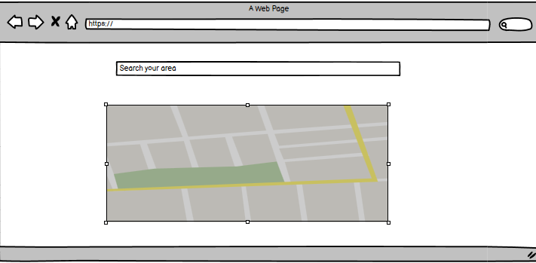
Initial wireframe showcasing search functionality and Google Maps integration.

2. Design Decisions
Design Principles
- UI/UX: Minimalist interface with intuitive navigation.
- Color Scheme: Blue (#007BFF) for trust, green (#28a745) for success actions.
- Typography: Arial (sans-serif) for readability.

Rationale
- Color Choice: Blue aligns with healthcare branding; green highlights positive actions (e.g., "Confirm Booking").
- Grid Layout: Ensures consistency across devices (desktop, tablet, mobile).

Visual Examples

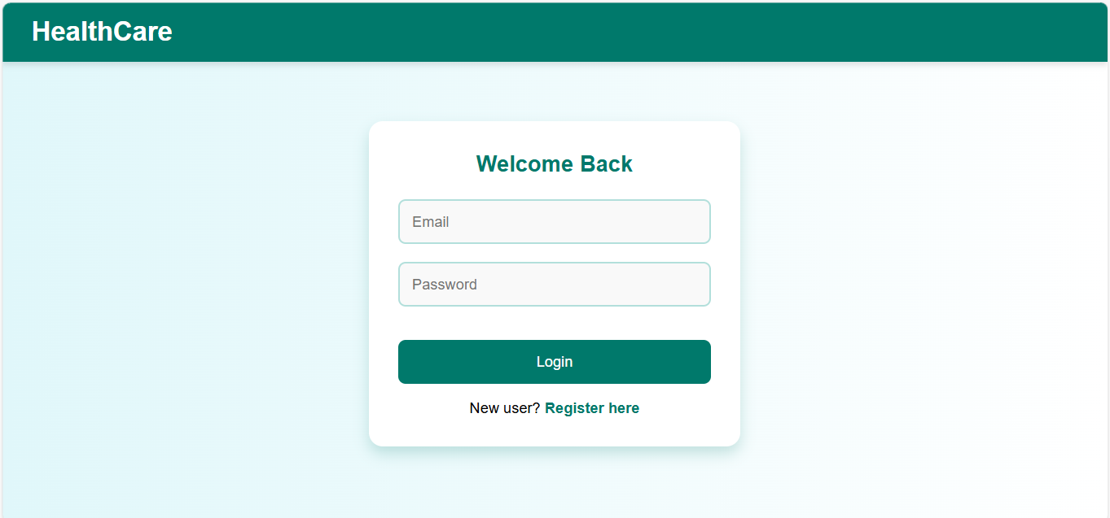
Clean login interface with input validation and error feedback.

3. Development Process

component | Tools
Frontend(bootstrap 5)  Backend(interactions)  Database  APIS | HTML5, CSS3, JavaScript  PHP(PDO for database)  MYSQL  Google Maps JavaScript API, Geocoding API

Development Stages
1. Database Design: Created relational tables (`users`, `doctors`, `appointments`).
2. Frontend Development: Built responsive UI with Bootstrap.
3. Backend Integration: Implemented secure authentication and CRUD operations.
4. API Integration: Added Google Maps for location services.

Challenges
- Securing Google Maps API key
- Cross-device responsiveness

Solutions
- Stored in `.env` file; restricted usage in Google Cloud Console.
- Tested using Chrome DevTools; used Bootstrap’s grid system.

4. Testing and Deployment
Testing Strategies
- Functional Testing: Verified form submissions, appointment workflows, and error handling.
- Responsiveness: Tested on iPhone 12, iPad Pro, and desktop browsers.
- Security: SQL injection prevention via prepared statements.

Deployment
- Local Server: Hosted temporarily on XAMPP (`http://localhost/healthcare-app`).
- Future Plan: Deploy to Heroku with ClearDB MySQL add-on.

Testing Evidence



Mobile and desktop views demonstrating responsiveness.

5. Conclusion and Reflection
Key Takeaways
- Mastered full-stack development (frontend, backend, database integration).
- Learned to implement secure authentication and API interactions.

Reflection
- Strengths: Effective use of version control (GitHub), clean code structure.
- Improvements: Allocate more time for user testing and edge-case handling.

Future Enhancements
- Add telemedicine features (video consultations).
- Integrate payment gateway for premium services.

GitHub Repository
Link: https://github.com/pheno257/healthcare-appointment-system
Repository Includes:
- Full source code (HTML, CSS, PHP, SQL).
- Documentation (setup guide, `.env` template).

6. Appendix
Code Snippets
php
// Database Connection (db.php)
<?php
require_once __DIR__ . '/autoload.php';
$dotenv = Dotenv\Dotenv::createImmutable(__DIR__);
$dotenv->load();

try {
$conn = new PDO(
"mysql:host=" . $_ENV['DB_HOST'] . ";dbname=" . $_ENV['DB_NAME'],
$_ENV['DB_USER'],
$_ENV['DB_PASS'],
[PDO::ATTR_ERRMODE => PDO::ERRMODE_EXCEPTION]
);
} catch (PDOException $e) {
die("Connection failed: " . $e->getMessage());
}
?>

Screenshots
- User Registration Page
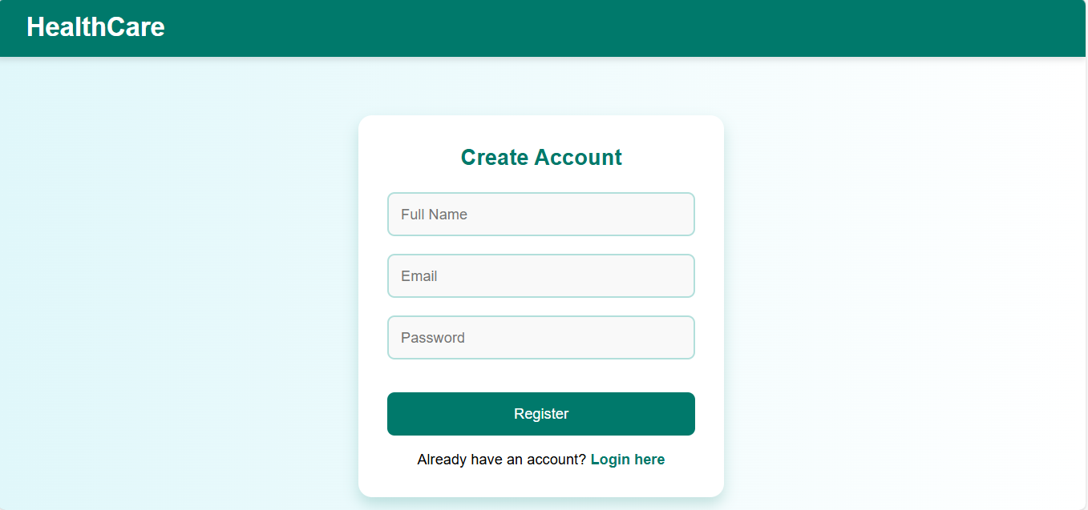

2. Doctor Search Interface

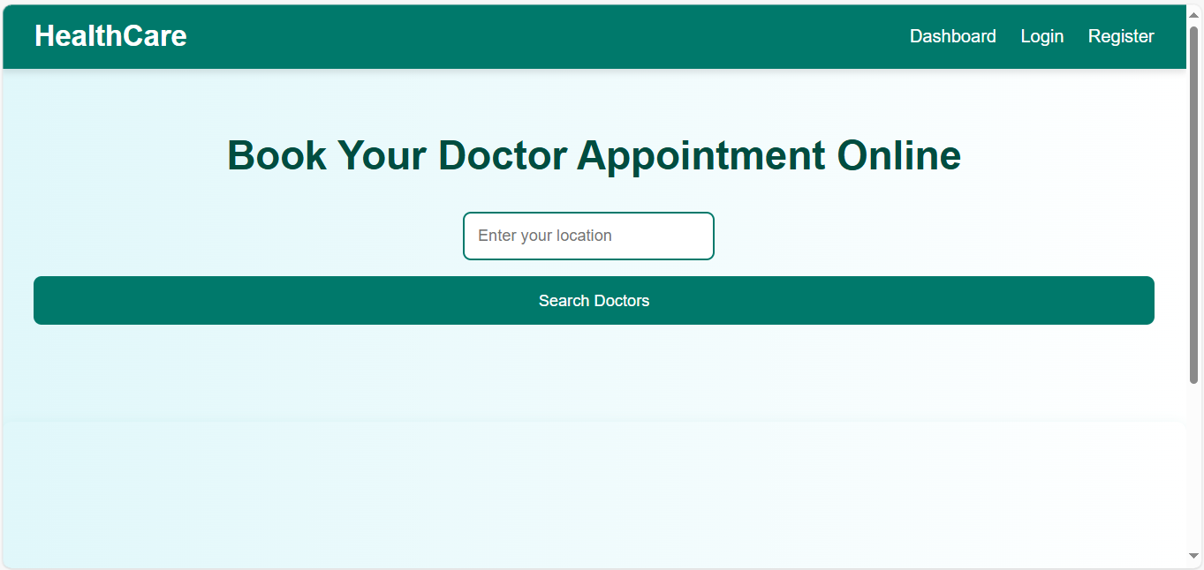

Declaration
I confirm that this report is my original work and adheres to the academic integrity guidelines of Mbarara University of Science and Technology.

